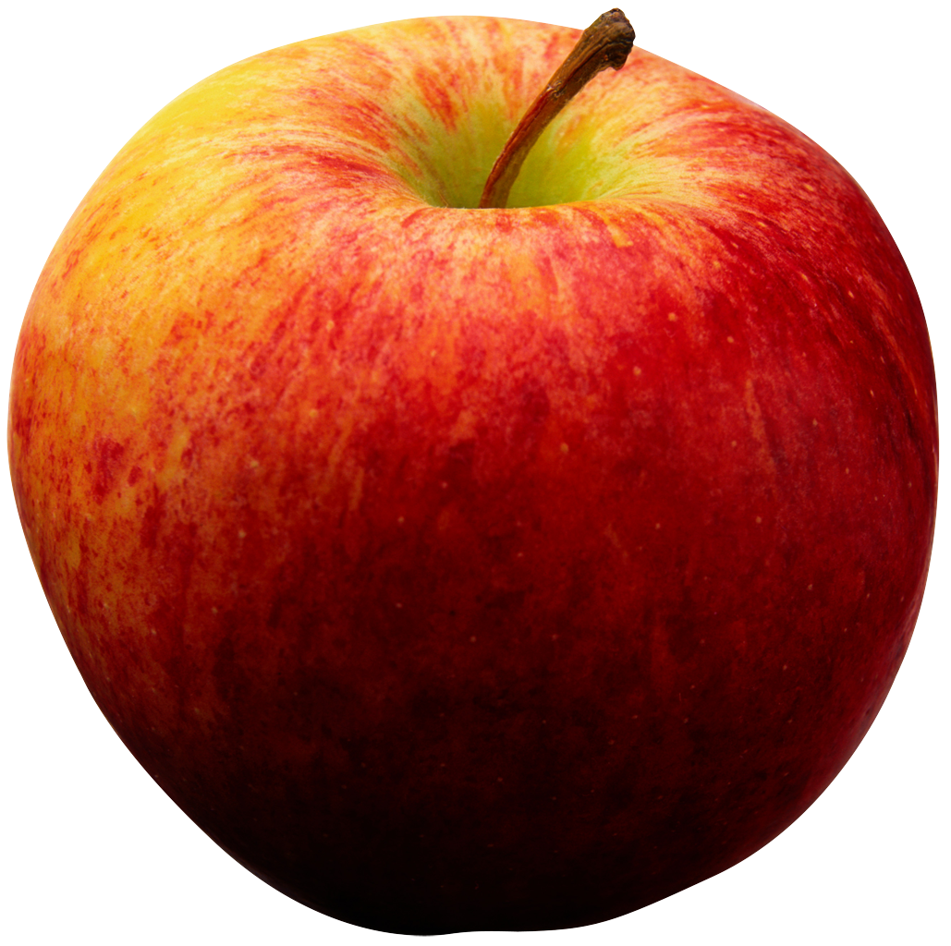 EATING THE RAINBOW 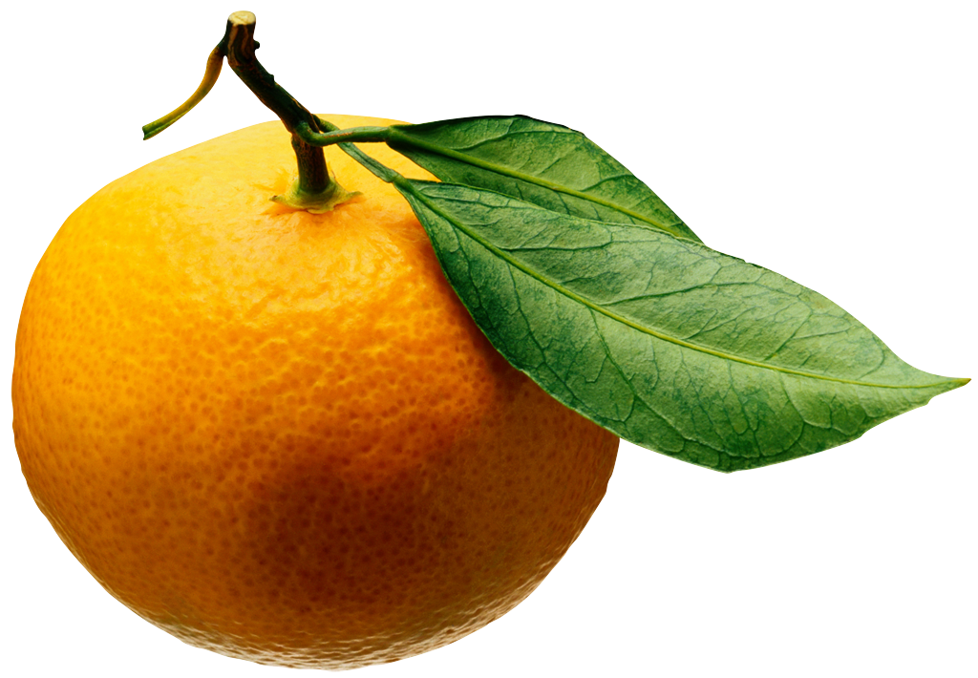
Are you eating enough fruits and vegetables?
The USDA recommends:
- 2 cups fruit/day
- 2 ½ cups vegetables/day
_____________________________________________________________

Eating MORE fruits and vegetables has many health benefits:

- Keeps your heart healthy
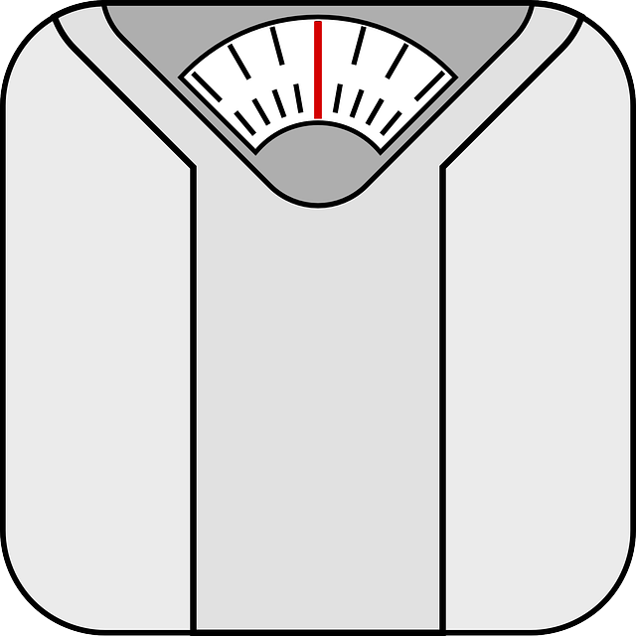
- Helps manage weight
- Reduces risk of adult diabetes

- Improves mental health
- Lowers blood pressure
- And more!

________________________________________________________

Fruits & Vegetables come in many forms! Know the servings sizes:
- 1 cup 100% fruit juice = 1 cup of fruit
- ½ cup dried fruit = 1 cup of fruit
- ½ cup sliced whole fruit = ½ cup of fruit
- 1 cup cooked vegetables = 1 cup of vegetables
- 1 cup dry green leaves = ½ cup of vegetables
_______________________________________________________

Easy tips:
- Frozen fruits and vegetables are just as healthy as fresh ones!
- Swap a soda for 100% fruit juice
- Bring dried fruits like raisins for a snack that will not rot
- Shop the outside parts of the grocery store more than the aisles
________________________________________________________________________

EASY RECIPES TO EAT MORE FRUITS AND VEGETABLES

Tropical Smoothie Recipe (2 ½ servings of fruit)

- 1 cup orange juice
- 1/2 cup frozen fruit
- 1/4 cup fruit yogurt
- 1/4 cup spinach

Place in blender with ice and blend until smooth

______________________________________________________________________________

Vegetarian Casserole:

- Warm 20 ounces of mixed vegetable packet of carrots, corn, peas in a pan over low heat
- Combine cooked vegetables with 1 cup chopped white onion and 1 cup chopped celery over low heat
- Add ½ cup mayonnaise and 1 cup shredded cheddar cheese
- Stir mixture until cheese is melted
- In a separate bowl, combine 1.5 cups Ritz crackers with ½ cup melted butter
- Spoon vegetable mixture into greased baking dish, and sprinkle butter and crackers on top
- Bake at 350 degrees for 30-35 minutes until warm
__________________________________________________________________________

Microwave apple pie:
- Chop green apple into small cubes
- Drizzle with honey
- Sprinkle cinnamon sugar over
- Microwave with ½ tablespoon of butter for 2 minutes
- Stir and serve when cool

