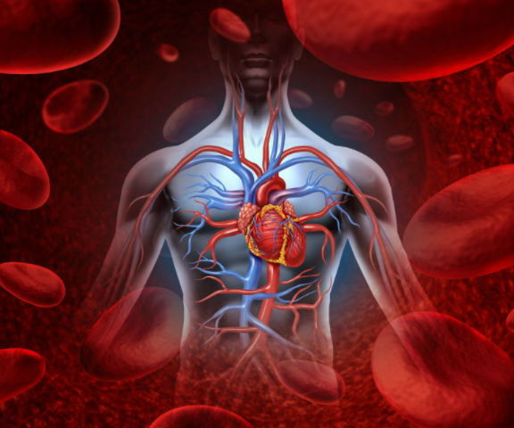 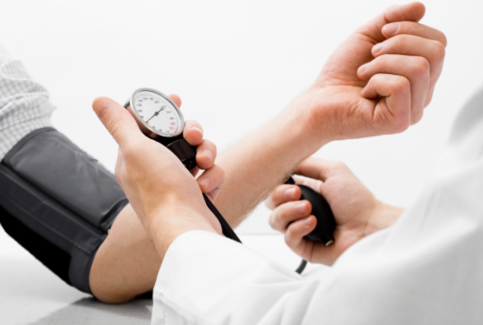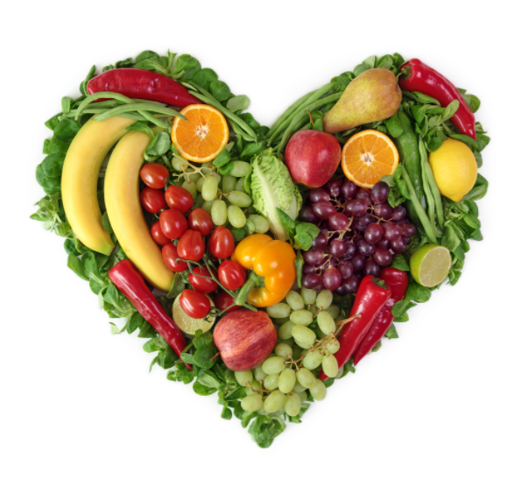 

|  |  |  |
| --- | --- | --- |
|  | Systolic (Top Number) | Diastolic (Bottom number) |
| **Normal** | <120 | <80 |
| **Pre- Hypertensive** | 120-139 | 80-89 |
| **Hypertensive Stage I** | 140-159 | 90-99 |
| **Hypertensive Stage II** | 160-179 | 100-109 |
| **Hypertensive Crisis** | 180> | 110> |

## **How High is too High?**

Many lifestyle changes can help lower high blood pressure,

* Weight loss
* DASH Diet: consuming a diet high in fruits, vegetables, and fiber and lower in fats.
* Lowering sodium intake: choosing fresh foods without preservatives and limiting salt as a seasoning
* Physical activity: exercising for 30 minutes on most days of the week.
* Moderating Alcohol Consumption: limiting alcohol consumption to 1-2 drinks per day

Lifestyle and Hypertension

Hypertension

Many lifestyle changes can help lower high blood pressure,

* Weight loss
* “DASH Diet” food choices:
  + consuming a diet high in fruits, vegetables, and fiber and lower in fats.
  + Examples include skim or low-fat milk and dairy,
* Lowering sodium intake: choosing fresh foods without preservatives and limiting salt as a seasoning
* Physical activity: exercising for 30 minutes on most days of the week.
* Moderating Alcohol Consumption: limiting alcohol consumption to 1-2 drinks per day



Hypertension, or high blood pressure, simply describes pressure in the arteries that is higher than normal. This condition is usually symptomless and can only be recognized by a doctor but is still very dangerous. Uncontrolled high blood pressure can increase your risk of stroke, heart attack, angina, heart failure, kidney failure and peripheral arterial disease (PAD).

# Hypertension and You