“Down to Get High”
The Effects of Regular Marijuana Use on Brain Development and Function

Tess Clancy

Kinesiology 307: T/R 9:35am

References

Mokrysz, C., Freeman, T., Korkki, S., & Curran, H. (2016). Are adolescents more vulnerable to the harmful effects of cannabis than adults? A placebo-controlled study in human males. Translational Psychiatry, 6(11), 1-10.

Dager, Alecia D., et al. (2018). Relationships between fMRI response during a nonverbal memory task and marijuana use in college students. Drug and Alcohol Dependence, 188(1), 71-78.

Introduction

The brain is the last organ to reach full maturity in humans. While most other functions of the body have been long established, neuromaturation of the prefrontal cortex continues even into late adolescence. Even after maturation, brain plasticity still allows for some degree of altered function throughout the lifespan. Because of this, any substance that alters brain growth or development is a top priority for research.
Cannibas, or marijuana is an increasingly common recreational drug containing a psychoactive substance known as THC. Recently, new legislation has begun to legalize medical and recreational cannibas use in many areas of the world. However, research shows that regular THC use is correlated with poorer memory function, decreased hippocampus and decreased frontal lobe function. A growing body of research also implies that adolescents may particularly vulnerable to these effects because of their place in development.

In chapter 2 of the textbook (pages 53-57), changes in developing brain structure as well as the concepts of brain plasticity and how aging influences neurological changes are addressed. Additionally, memory functions are outlined in chapter 7.

Two specific studies analyzed below investigated these topics as they relate to marijuana usage. The first study analyzed two different age cohorts of regular-marijuana users and investigated the short-term effects of marijuana inhalation on memory function. The second study analyzed fMRI data from college-aged participants with varying levels of regular marijuana usage while they completed a non-verbal memory and recognition task. Together, these studies provide a broadened view of how marijuana affects the growth and development of the brain.

Intent study 1

This study’s intent was to study the immediate effects of marijuana inhalation on three aspects of memory function: spatial working memory, response inhibition, and episodic memory on both adults and adolescent males. Researchers wanted to test if adolescents would be more influenced by certain cannabis effects given their place in development.
Method study 1

Researchers chose 20 male participants between 16-17 years old, and 20 male participants between 24-28 years old to participate in a double-blind experiment. All participants self-reported their current recreational marijuana use of 1-3 times per week, for at least the past 6 months. All participants were assessed for verbal intelligence, any other illicit drug use, BMI, heart rate, and blood pressure. Each individual also scored at or below 3 on the Cannibas Severity of Dependence Scale.

Before being introduced to any experimental conditions, each participant answered private survey questions rating their feelings on a number of matters including “alertness,” “drug high,” “anxiety level,” “paranoia,” “desire for food” and “desire for cannabis” on a scale of 0-10, 0 meaning “not at all” and 10 being “extremely”. The participants also completed 2 memory tasks and 1 response inhibition task for a baseline reading.

The first memory task tested “prose recall”, where researchers played a 30 second story and gave participants 1 minute immediately afterwards to write down everything they could remember from the story. The story contained 21 distinct concepts they used to score recall ability. The second memory task tested spatial memory and working memory with the “Spatial N-Back test”. This test showed stimuli in several possible locations on the screen and asks participants to respond “yes” or “no” if the stimulus was in the same place as the picture 1 before or 2 before. Finally, the third memory task tested response inhibition with the Stop Signal test. During this test, a series of white arrows facing either left or right would be displayed on a screen, and the participant would be instructed to press a button with their left or right hand according to which direction the arrow faced. However, at random, the arrow would become blue instead of white and when this happened, participants were told not to press either button.

One week after the first series of tests to provide the baseline test results, participants came back and were subjected to experimental conditions. Each age group was randomly given either a medical-grade active THC dosage (12% potency) dosed to their body weight, or a placebo substance and instructed on how to inhale the substance.

The 3 cognitive tasks were performed again, the same private survey was given and heart rate and blood pressure were recorded. Results were analyzed using independent t-test, chi-squared tests, and Mann-Whitney U statistical tests.

Results/Discussion study 1

As expected, both the adult and adolescent groups had higher reporting of “high” feelings when they had ingested the drug as opposed to ingesting the placebo. However, overall the adolescent group reported feeling more alert and less anxious after ingesting the drug when compared to the adult group counterpart. Additionally, the teens reported that their desire for more cannabis after the experiment had increased (p = .048), whereas the adults desire for more cannabis had decreased after consuming the substance (p = .031). Adult participants also had higher heart rates (p < .001) and diastolic blood pressures (p = .016) after ingesting the drug than the adolescent group that had also ingested the drug.

The cognitive test results produced both expected and unexpected results. Both adults recalled less story items from the prose test after cannabis compared with their respective placebo groups. The Spatial N-back test showed that discrimination of tasks was worse for both adults and adolescents on cannabis as compared with their placebo equivalents but with no documented significant differences between the two age cohorts. Finally, the Stop-signal test results showed that adolescents were less accurate on cannabis than their placebo counterpart (p = .001). However, the drug did not affect the adult group’s accuracy on the same task (p=0.644).

Overall, the results that the self-reported survey and physical measurements showed that the adolescent group seemed to feel the effects of marijuana less severely than the adult group did and want the drug more after consuming it than the adults did. Researchers hypothesized that if the intoxicating effects of marijuana are less noticeable in adolescents than adults as this study would imply, it may lead to adolescents consuming a higher quantity of marijuana and with more frequency than adults. Teens increasing their exposure in order to get the subjective benefit of the drug, could potentially lead to more detrimental cognitive effects on their developing brain.

Importantly, this study showed that while teens subjectively reported that they felt the drug effects less than the adults, in reality they were just as affected and even more affected than the adults on the cognitive function tests.

Critique study 1

Several experimental shortcomings can be found in this study. First, all participants were male and so it is not possible to rule out if these results are gender-specific. Secondly, this study used participants that had regular, past cannabis use, and like many illicit drugs, there could be a tolerance effect and the results could be even stronger than represented in this study. Finally, this study examined closely the acute effects of cannabis use, but more studies could examine the long-term influence on memory and cognitive functions.

Intent study 2

This study’s purpose was to examine and analyze fMRI data from college-student marijuana users while completing non-verbal memory tasks. Researchers proposed that because the hippocampus and frontal lobe, specifically the inferior frontal gyrus (IFG) have a high number of cannabis receptors, these areas may be particularly vulnerable to decreased function under the influence of cannibas, as other studies have also implied.

Method study 2

Researchers collected 60 college-aged students (18-22 years old) and virtually surveyed them once a month for three months prior to beginning the experiment. Each survey asked participants about their marijuana use, other drug use and alcohol use. The survey offered a scale of 1-6, 1 being “never used the substance in the past 30 days” and 6 being “used the substance equal to or more than 20 times in the last 30 days”. Participants were divided into two groups: those with no marijuana use, and those with some marijuana use in the last 3 months.

Before the experiment began, each participant was given a breathalyzer test, a urine toxicity test, and females were given a pregnancy test. All tests had to be negative for alcohol, any drugs besides marijuana, and pregnancy before beginning the experiment.

The “figurative memory task” is designed to test visual encoding without any verbal cues. Participants in this experiment watched a screen and were told to memorize 20 random pictures made with black lines. Each picture displayed for 3 seconds, and other distractor stimuli were shown on the screen as well. After five minutes, recognition of the shapes was tested. 20 pictures and 20 distractors were displayed and participants were asked to press the button in their right hand if they had seen the picture before, and press the button in the left hand if they had not seen the picture before.

During these tests, participants were hooked up to fMRI apparatus. The responses from the figurative memory task were divided into 4 groups: correct hits, misses, correct rejections and false alarms (incorrect rejections). Researchers used independent t-tests to analyze results between groups. The two main regions of interest, the hippocampus and the IFG region were defined, and broken into left and right hemispheres. The blood oxygen level dependent (BOLD) fMRI data was also analyzed using independent t-tests. Additionally, researchers conducted an exploratory whole-brain analysis on each participant, and analyzed the other factors listed on the survey such as alcohol use, other illicit drug use, smoking and gender.

Results/discussion study 2

In general, there was not much variation on how the two groups did with regard to the number of hits, misses or correct rejections. However, exploratory analysis showed that a general trend exists for the marijuana user group to have a higher number of false alarms.

More interesting results appeared when fMRI analyses were completed. During the encoding phase, where participants were memorizing the figures for the first time, there were no significant functional differences in either region of interest. However, during the recognition phase, the marijuana-using group showed less BOLD fMRI activity in the right and left hippocampus (p = .039, and p = .013 respectively) as well as in the left IFG (p = .023) during correct memory identification (“hits’) when compared with controls. Whole brain analyses also showed decreased activity in marijuana users in additional areas, including most notably the cerebellum, the basal ganglia, and left posterior parietal cortex. A graphical summary is included below for reference.

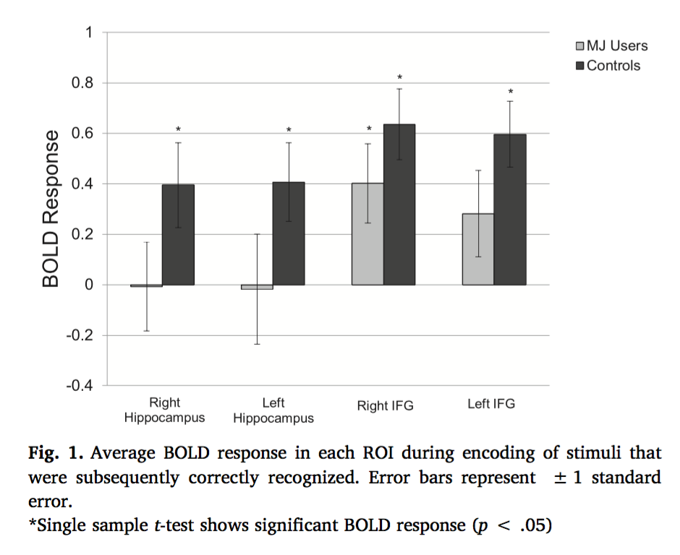

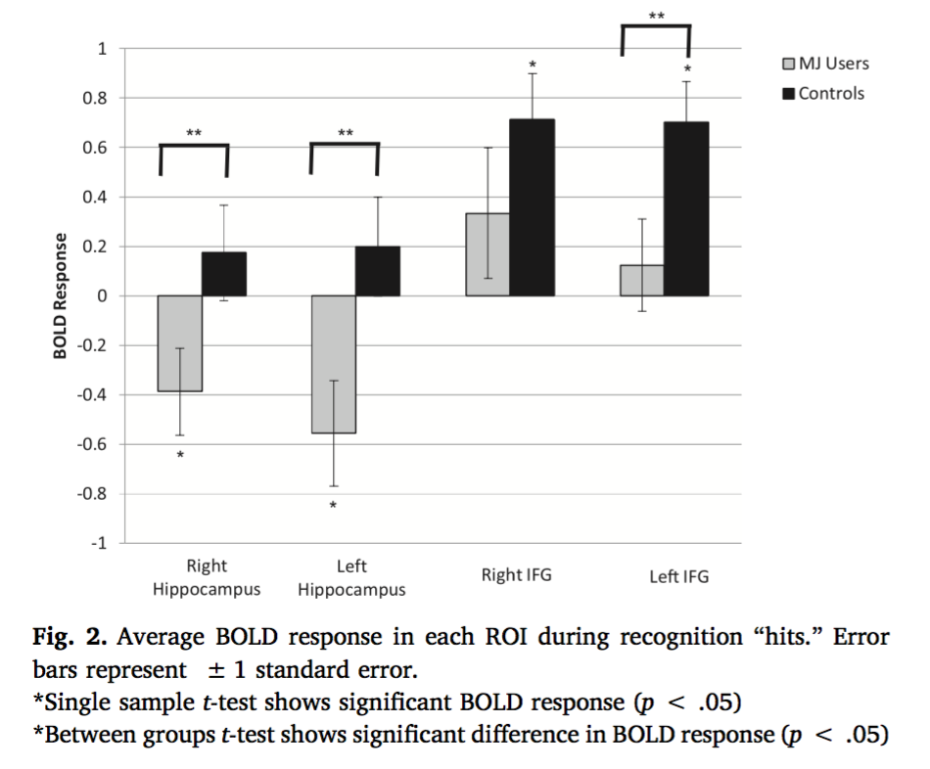

A

The results of this study define a difference in brain function during memory tasks for participants that smoked marijuana regularly and those that did not. The encoding phase (memorizing) does not seem to be influenced by marijuana use, but the recognition phase does seem to be influenced by marijuana use. Marijuana users rely less on the hippocampus and IFG when recognizing stimuli than controls do; and more frequent marijuana use seems to amplify that effect.

The IFG region and hippocampus of the brain are used heavily in long-term memory retrieval. Thus, researchers speculated that the decreased activity in these two areas in the marijuana use might imply that long-term memory retrieval is more influenced by marijuana use than short-term memory. Other studies have had similar results, implying that the prefrontal cortex and the hippocampus of the brain are the most influenced by frequent marijuana use. Interestingly, these are also among the last parts of the brain to fully develop.

Critique study 2

This study used self-reported online survey answers to assess marijuana usage in the previous 3 months. Because marijuana is still illegal in most parts of the country, we cannot rule out that respondents may have been untruthful in their responses. College-aged students also have many other factors not controlled for in the results of this study, such as stress and hormonal responses. This study also did not investigate long-term marijuana use, but only recent marijuana usage.

Other similar studies that have investigated the role of the IFG and hippocampus in long-term memory retrieval have found that marijuana users had more false alarms in memory tasks, but also worse delayed retrieval in memory tasks. This study could have been made stronger by asking participants to do the recall task with more time between the two stimuli.

Finally, changes in brain structure and brain structure function can be found in many different types of individuals. It is always possible that the changes seen in fMRI data would have existed before the marijuana usage. Potentially, the altered brain function could have lead to a predisposition for marijuana use in the first place.

Summary

The topic of how marijuana use influences the brain circuitry and development is crucial. With a high abuse rate and increasing availability, adolescents are at the most vulnerable social position to be influenced by dependency on marijuana. Combined, these two studies show that brain memory function involving the prefrontal cortex is reduced with both acute and with regular marijuana use. Because of the adolescent’s developmental stage and the growing maturity of that portion of the brain, it is crucial to understand if marijuana use poses a long-term risk to memory function. More research should be completed to answer this question.

